THOUSAND SONS SPECIAL RULES
The following special rules apply to Chaos formations and units.

TS1 STRATEGY RATING
Further, Thousand Sons armies contain potent seers to foresee the future and plan attacks. Thousand Sons armies have a strategy rating of 5.

TS2 INITIATIVE RATING
Thousand Sons Aircraft formations (Doomwings and Firelords) and Silver Towers have an initiative of 2+. All other formations have an initiative rating of 1+.

TS3 SUMMONED UNITS
Certain units may be summoned to appear at the start of a Thousand Sons formation’s action through the use of the Daemonic Pact upgrade. Formations that purchase the Daemonic Pact as an upgrade are capable of summoning daemons to the battlefield. In order to have daemons to summon players must purchase a single Daemon Pool from which all formations with the Daemonic Pact upgrade will summon from. Players should either write down the contents of their Daemon pool or use tokens to indicate the number of each type of Daemon they have available. The Thousand Sons player’s opponent is always able to view the number of daemons (and their type) remaining in the Daemon Pool. The Daemon Pool is kept off the board and daemons are removed from it as formations summon daemons onto the board.
At the start of that formation’s action, before the action test dice roll is made, the formation may summon daemonic units from the Daemon Pool. Summoning allows you to call 2D3 summoning points worth of daemonic units to the battlefield (the number of summoning points it costs to summon a unit are listed below in parentheses after each unit). Summoning points must be used to summon daemonic units from the Daemon Pool and summoned units are brought into play immediately. If for any reason any summoning points generated are not used, they are lost and may not be carried over into subsequent turns. You may only summon as many daemons as you have left in your Daemon Pool. Left over daemonic units may be summoned during a later turn. Daemonic units that are destroyed are removed from play and are not put back into the Daemon Pool. Broken formations or formations that have not bought a Daemonic Pact
may not summon daemons.
Players may only have one greater daemon on the board at one time. Summoned units must be set up with their base within 5cm of any non-daemonic unit from their formation, (i.e. you cannot place a “chain” of summoned units). They may not be set up in the Zone of Control of an enemy unit or in impassable terrain.

The types of units that can be summoned by the Thousand Sons are Lord of Change: Greater Daemon of Tzeentch (8); Tzeentch Flamers (1), Tzeentch Horrors (1) and Tzeentch Screamers (1).

Summoned units count as part of the formation for all rules purposes as long as they remain on the battlefield. The only exception to the normal rules is that the loss of a summoned unit does not cause a blast marker to be placed on the formation. They are otherwise counted as normal units, and are included when working out if a formation outnumbers an opponent in an assault or is broken by blast markers, etc.
Note that Daemons that are killed in an assault do count towards the number of units killed by the enemy when working out modifiers to the result dice roll. Summoned units remain on the battlefield until the end phase of the turn in which they are summoned. In the end of the rally phase, after formations have attempted to rally, all summoned units in the formation are removed from the board and placed back into the Daemon Pool unless the formation has a unit with Daemonic Focus (see TS6 below). Greater Daemons that are returned to the Daemon Pool keep the same DC they had when they left the battlefield. They do not heal back to full DC, so when summoned again they will have that same DC. Summoned units that are destroyed are not put back into the Daemon Pool. Note that this may lead to the formation breaking if the number of Blast Markers on the formation is greater than the number of units left in play
after the summoned units have been removed. When a formation breaks any summoned units in the formation are lost in the warp and considered destroyed. They do not go back into the Daemon Pool. Players are allowed to only summon one Greater Daemon to the battle at a time. So if you have already summoned one Lord of Change you are not allowed to summon another until that first Greater Daemon has been removed from play.

TS4 AUGMENT SUMMONING
Some Chaos units are noted as having Augment Summoning (+x). Units with this ability add a number of summoning points equal to "x" when the formation they are in summons daemons (see TS 1.1.4 Summoned Units). For example, a unit noted as having Augment Summoning (+2D3) would allow a formation with a Daemon Pack to roll 4D3 for Summoning Points as opposed to the usual 2D3.

TS6 DAEMONIC FOCUS
Certain Chaos units are noted as having Daemonic Focus. Units with this ability may keep any or all summoned units that belong to the formation in play. Summoned units do not vanish back into the warp after the formation has attempted to rally. Chaos units with Daemonic Focus may not be used to keep summoned units in play if the formation is broken.

TS7 FICKLE MASTERS
Tzeentch is quick to punish or reward Thousand Sons champions. In the strategy phase if the Thousand Sons player rolls a 6 they are rewarded for their tactical acumen with an additional 1d3 daemons to add to the Daemon Pool. If the Chaos player rolls 1 their patron Powers withdraw their support and the Thousand Sons player must remove 1D3 daemons from their Daemons Pool. If the Thousand Sons player has no remaining Daemon Pool they must remove a Thrall. If there is no Daemon Pool or Thrall then there is no further effect.

TS8 WEBWAY PORTAL
Webway portals are used by the Eldar to safely travel through the Warp. The Webway Portal included in the army allows the Thousand Sons player to pick up to three formations, and keep them back in the labyrinth between the Materium and the Warp. Any formation’s that are kept in the labyrinth between the Materium and the Warp may enter play via the Webway Portal, by taking an action that allows them to make a move, and then measuring their first move from the position that a Webway Portal occupies on the tabletop. No more than one formation may travel through each Webway Portal each turn.
In the Epic Tournament Game Rules formations in reserve with multiple deployment options must have a designated deployment method during setup (e.g. Webway Portal, air transport or teleport).

TS8 Daemon Prince
The supreme commander is either the sorcerer lord or the daemon prince, you may only have one of these in your army, either the lord or the prince, not both

TS8 Farsight

Thousand Sons Sorcerer Lord
Are 10,000 years old and the masters of sorcery are able to partially unravel the threads of time, allowing them to foresee events that may affect his army, and act to counter them. To represent this, any Thousand Son formation that includes a unit with Farsight may ignore the -1 Action test penalty when they try to retain the initiative. In addition, once per turn the Thousand Son r player may attempt to retain the initiative twice in a row (i.e. the Thousand Son player can retain the initiative and take another action after having successfully retained the initiative once already). Any Thousand Son formation may be chosen, including those that do not include a unit with Farsight, but at least one unit with Farsight must still be in play and on the battlefield. The formation must still pass an initiative test in order to carry out the action, and will suffer the -1 modifier for retaining the initiative unless it includes a unit with Farsight. Once the action has been taken the initiative returns to the opposing player

TS9 Warp Shield
Warp Palace of Tzeentch are protected by a Warp Shield
making it appear as a swirling cloud of coloured motes to the naked eye, while at the same time disrupting any targeting devices attempting to lock onto the Warp Palace . The overall result is to make the Warp Palace a very hard target to hit! Warp Shields provide the Warp Palace with a special 3+ saving throw that can be taken instead of the Palaces normal saving throw. This save may always be taken, even against hits in an assault or against Titan Killer or Macro-weapons attacks. Make a single saving against weapons with the Titan Killer ability, rather than a separate save for each point of damage. If a vehicle with a Warp Shield also has Reinforced Armour, then it is allowed to re-roll its saving throw unless hit by Lance, Macro-weapon or Titan Killer attacks, but the re-roll must be made using the units armour save rather than the Warp Shield save. No Blast markers are placed for hits that are saved by a Warp Shield .

THOUSAND SONS INDIVIDUALS - (Up to one of each type of individual may be taken per army.)

TYPE NOTES COST
0–1 Wraithgate At the start of the game nominate one objective on your half of the table as a Wraithgate before +50 points setting up spacecraft and garrisons. The Wraithgate functions both as a Webway Portal and as an
objective for the rules purposes. It may not be destroyed.
Only formations consisting completely of infantry units, light vehicle units or armoured vehicles units with the Walker ability

THOUSAND SONS RETINUES - (You may include any number of Retinues.)  FORMATION CORE UNITS |  | UPGRADES | COST
1+ Rubric Fellowship | 1 Thousand Sons Sorcerer and 6 Thousand Sons Marine units | All | 275 points
Thousand Sons Armour | 4 to 9 Thousand Sons Predators and/or Thousand Sons Land Raiders | Deceivers | 50 points per Predator  75 points per Land Raider
Silver Tower Company | 4 Silver Towers | None | 250 points

THOUSAND SONS SUPPORT FORMATIONS - (Up to two Support formations may be taken for each Rubric Fellowship selected)  UPGRADE CORE UNITS |  |  | COST
Thousand Sons Warcoven | 1 Thousand Sons Sorcerer and  4 to 6 Thousand Sons Terminator units | Daemonic Pact, Icon Bearer, Champion of Tzeentch, Deceivers, Dreadclaws, Land Raiders, | 350 points  +85 points per extra unit
Sekhmet Disc Riders | 1 Thousand Sons Sorcerer and 9 Disc Riders | Daemonic Pact | 325 points
Tzeetch Cult | One Demagogue or Chaos Marine Aspiring Champion and any eleven of the following units: Cultists, Mutants | Tzeetch Cult Upgrades | 200 points
Deceivers Formation | 4 Deceiver | Dreadnoughts | 275 points

THOUSAND SONS UPGRADES - (Each formation may take up to four allowed upgrades once per formation)  FORMATION UNITS |  | COST
0-1 Daemon Prince of Tzeentch | Replace a Sorcerer Lord with a Daemon Prince of Tzeentch | +50 points
Champion of Tzeentch | Add 1 Champion of Tzeentch. | +50 points
Sorcerer Lord  Daemonic Pact | Replace a Sorcerer with a Sorcerer Lord  Add one Lesser Daemon to the Daemon Pool. The formation may summon daemons. | +50 points  +25 points
Deceivers | Add up to 3 Deceivers | +75 points each
Dreadclaws | Transport a formation containing only infantry units and Chaos Dreadnoughts in Dreadclaws | +5 points per unit
Dreadnoughts | Add 1-3 Chaos Dreadnoughts to the formation | +50 points each
Icon Bearer | Add 1 Icon Bearer character | +25 points
Rhinos | Add up to 5 Thousand Sons Rhinos. You may only take the minimum number required to carry the entire formation. | +10 points each
Land Raiders | Add up to 4 Thousand Sons Land Raiders | +75 points each

THOUSAND SONS WAR ENGINE FORMATIONS - (Up to 1/3 of the total points may be spent on War Engines and Chaos Navy)

FORMATION CORE UNITS UPGRADES COST
Greater Spires 1 to 3 Greater Spires of Tzeentch Daemonic Pact, Champion of Tzeentch 200 points per unit
Warp Palace 1 Warp Palace Daemonic Pact, Champion of Tzeentch 550 points

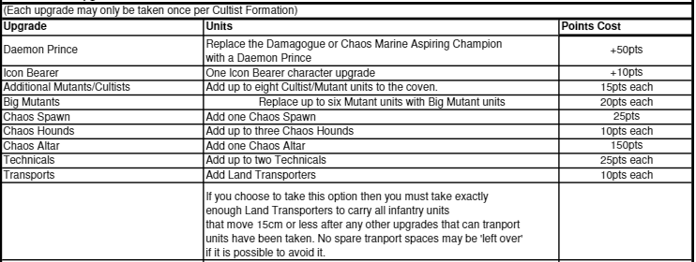

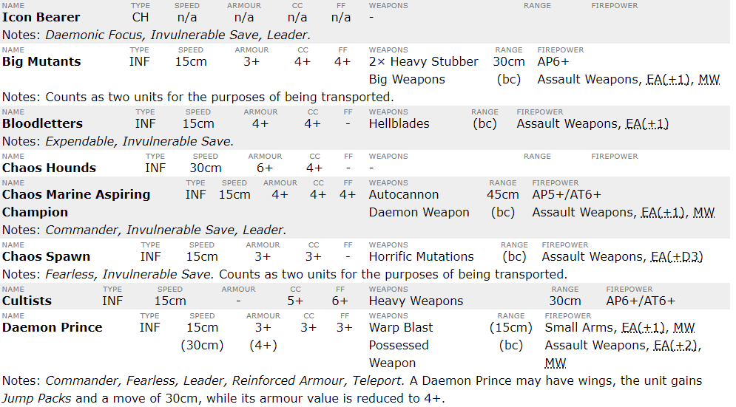
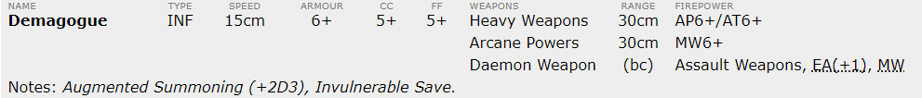
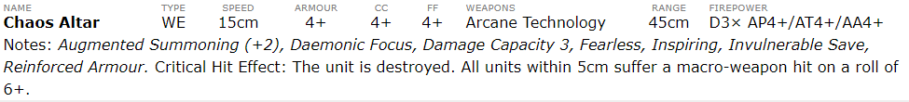

DAEMON POOL

(Only Tzeentch Daemons may be purchased for the Daemon pool)

FORMATION COST
0-1 Greater Daemon 50 points
Lesser Daemons 15 points each

THOUSAND SONS NAVY

(Up to 1/3 of the total points may be spent on War Engines and Chaos Navy)

FORMATION COST
3 Doomwing Interceptors | 150 points
- Firelord Bombers or  - Firelord Bombers | 250 points  350 points
1 Devastation Class Cruiser | 150 points
1 Despoiler Battleship | 250 points

NAME TYPE SPEED ARMOUR CC FF WEAPONS RANGE FIREPOWER NOTES
Icon Bearer
CH
n/a
n/a
n/a n/a n/a
n/a n/a
Leader, Daemonic Focus, Invulnerable Save
Thousand Sons Sorcerer CH n/a n/a n/a n/a Blue Fire (15cm) Small Arms, EA (+1), MW Leader, Commander
30cm AT4/AP4

Champion of Tzeentch
CH
n/a
n/a
n/a n/a Daemon Bolt
(15cm) Small Arms, EA (+1), FS
Augmented Summoning (+2D3), Invulnerable Save.
Daemon Artifact (bc) Assault Weapons EA (+1), FS

Thousand Sons Sorcerer Lord
INF 15cm 4+ 4+ 4+ Sorcerous Weapons 45cm AP5+/AT6+ Supreme Commander, Reinforced Armour, Fearless, Teleport
Pink Fire 30cm MW5+

AND (15cm) Small Arms, EA (+1), MW
Daemon Prince of Tzeentch INF 15cm 3+ 3+ 3+ Daemon Weapon (bc) Assault Weapons, EA (+1), MW Supreme Commander, Reinforced Armour, Fearless, Teleport,DC2
Bolt of Change 45cm MW4+
2 x Warp Bolt (15cm) Small Arms, EA (+1), MW
Thousand Sons Marines
INF
15cm
5+=+
5+ 4+ Bolter
(15cm) Small Arms
Reinforced Armour, Fearless
Soulreaper cannon 30cm AP5+/AT5+
Sekhmet Disc Riders INF 30cm 4+ 3+ 4+ Sorcerer Powers (15cm) Small Arms Mounted, Skimmer
Thousand Sons Terminators INF
15cm
4+
4+ 3+ Power Weapons
(bc) Assault Weapons, EA (+1), MW Reinforced Armour. Thick Rear Armour. Fearless, Teleport
Combi-Bolters (15cm) Small Arms, EA (+1

)
Soulreaper cannon 30cm AP5+/AT5+

Deceiver AV 20cm 4+ 4+ 3+ Battle Cannon 75cm AP4+/AT4+ Fearless, Invulnerable Save, Walker
Ether Cannon 45cm 2x AP5+/AA6+

Twin Heavy Flamer 15cm AP3+, IC

AND (15cm) Small Arms, IC

Battle Claws (bc) Assault Weapons, EA (+1), MW

Warp Flame (bc) Assault Weapons, EA (+1), FS
Silver Tower
AV
20cm
4+
6+ 4+ 3 x Arcane Cannons
45cm AP4+/AT4+
Skimmer, Invulnerable Save, Fearless
Beam of Power 60cm MW5+
Thousand Sons Rhino AV 30cm 5+ 6+ 6+ Combi-Bolters (15cm) Small Arms Transport: (May carry 2 of the following units: TS Marines, TS Sorcerer
Lord, TS Adeptus, Daemon Prince of Tzeentch, TS Neophyte).
Thousand Sons Land Raider AV
25cm
4+
6+ 4+ Twin Heavy Bolter
30cm AP4+
2x Twin Lascannon 45cm AT4+
Reinforced Armour, Thick Rear Armour, Transport: (May carry 1 TS
Terminators or 2 of the following units: TS Marines, TS Sorcerer Lord, Daemon Prince of Tzeentch, TS Adeptus, TS Neophyte).

NAME | TYPE | SPEED | ARMOUR | CC | FF | WEAPONS | RANGE |  | FIREPOWER | NOTES
 |  |  |  |  |  | Warp Flame | (bc) |  | Assault Weapons, EA (+1), FS
Thousand Sons Predator | AV | 30cm | 4+ | 6+ | 4+ | Twin Lascannon | 45cm |  | AT4+
 |  |  |  |  |  | 2x Heavy Bolter | 30cm |  | AP5+
 |  |  |  |  |  | Warp Flame | (bc) |  | Assault Weapons, EA (+1), FS
Greater Spires of Tzeentch | WE | 20cm | 4+ | 5+ | 4+ | 3 x Arcane Cannons | 45cm |  | AP4+/AT4+ | DC3, Skimmer, Thick Rear Armour, Invulnerable Save, Fearless, Daemonic
Focus Critical Hit Effect: Destroyed; each unit within 5cm takes a MW hit on
Beam of greater Power 60cm MW4+ a roll of 6.
Fate of Tzeentch 30cm MW2+, Titan Killer (1)
Warp Palace of Tzeentch | WE | 20cm | 4+ | 4+ | 3+ | 4x Arcane Cannons | 45cm |  | AP4+/AT4+ | Skimmer, Reinforced Armour, Thick Rear Armour, Warp Shield Save, Fearless, Daemonic Focus. DC 6. Critical Hit Effect: One of the Silver
 |  |  |  |  |  | 2x Beam of greater Po  Warp Fire of Tzeentch | wer 60cm  30cm |  | MW4+  3BP, TK(d3), IC | Runes that channel the power of the warp is shattered, releasing a storm of warp energy. It takes an extra point of damage; each unit within 5cm takes a
 |  |  |  |  |  |  |  |  |  | MW hit on a roll of 6.
Lord of Change | WE | 30cm | 4+ | 5+ | 3+ | Bedlam Staff | (bc) |  | Assault Weapons, EA (+1), MW | DC3, Reinforced Armour, Invulnerable Save, Walker, Jump Packs, Inspiring,
Fearless, Daemonic Focus, Expendable, Critical Hit Effect: Hurled back into
Withering Gaze (15cm) Small Arms, EA (+1), MW the warp. Drags any units with in 5cm back with it on a roll of 6+. Costs 8
AND 45cm 2x MW3+ points to summon.
Tzeentch Flamers | INF | 15cm | 5+ | 5+ | 4+ | Flames of Tzeentch |  | (bc) | Assault Weapons | Expendable, Invulnerable Save. Costs 1 point to summon
 |  |  |  |  |  |  | AND | (15cm) | Small Arms, EA (+1)
Tzeentch Horrors | INF | 15cm | 4+ | 4+ | 3+ | Daemonic Fire |  | (15cm) | Small Arms | Expendable, Invulnerable Save. Costs 1 point to summon
Tzeentch Screamers | INF | 30cm | 5+ | 3+ | n/a | Claws and Fangs |  | (bc) | Assault Weapons | Expendable, Jump Packs. Invulnerable Save. Costs 1 point to summon
Doomwing | AC | Fighter | 6+ | n/a | n/a | Flame Cannon |  | 15cm | AP4+/AT5+/AA5+, IC, FxF | Invulnerable Save
Firelord | AC | Bomber | 4+ | n/a | n/a | Flame Cannon |  | 15cm | AP4+/AT5+/AA5+, IC, FxF | Invulnerable Save
 |  |  |  |  |  | Firestorm Bombs |  | 15cm | D3 BP, IC, FxF
 |  |  |  |  |  | Twin Lascannon |  | 45cm | AT4+/AA4+, FxF
Devastation Class Cruiser | SC | n/a | n/a | n/a | n/a | Orbital Bombardment |  | - | 3 BP, MW | Transport: (May transport 20 infantry units or TS Dreadnoughts; plus
 |  |  |  |  |  |  |  |  |  | enough Dreadclaws to transport them.)
 |  |  |  |  |  | Pin-point Attack | - MW2+, TK (D3)
Despoiler Class Battleship | SC | n/a | n/a | n/a | n/a | Orbital Bombardment | - 3 BP, MW |  |  | Slow and Steady, Transport: (May transport 40 infantry units or TS
 |  |  |  |  |  | 3x Pin-point Attack |  | - | MW2+, TK (D3) | Dreadnoughts; plus enough Dreadclaws to transport them.)

NAME TYPE SPEED ARMOUR CC FF WEAPONS RANGE FIREPOWER NOTES

Dreadclaw
Special n/a
n/a
n/a n/a -
Planetfall, Transport: (May transport one formation of infantry units and TS
Dreadnoughts.) The Dreadclaw does not scatter 2d6cm after being placed within 15cm of the drop zone co-ordinates recorded at the start of the game. Any troops carried in the Dreadclaw must disembark within 5cm of the Dreadclaw or within 5cm of another unit from the same formation that has already landed, so long as all units are placed within 15cm of the Dreadclaw. Dreadclaw models should be removed from the board once the formation they transport has disembarked.

