unit data:
type: what target type
Speed: in cm
armour: roll equal or higher to save
close combat: rating when charging/being charged
firefight: short ranged firefight rating
weapons: can be multiple x2 weapon types
range: range of weapons
firepower: ap - anti personnel and at anti-tank use either/or
value is score to hit on d6
formations: 5cm chain - must always form up if broken up
starting step:
strategy phase: roll d6 add strategy rating highest chooses first or second
action phase: alternate actions with units
end phase: rally formations with blast markers, check victory conditions

Action phase:
Rotate activations
Nominate, declare formation action, pass action test
Roll d6 must be equal or over initiative, fails can still hold order but get a blast marker
Blast markers cause a -1 modifier and a further -1 to retain initiative
Can only retain initiative, max twice in a row then pass over turn
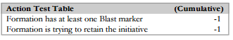
ACTIONS:
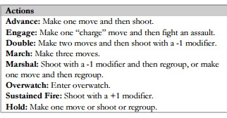
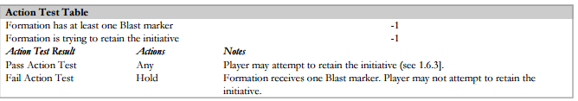
MOVEMENT:
take one movement turn after another if more than one move
Cannot move over enemy units. Friendly infantry can move through friendly units.
units have 5cm zone of control that cannot be moved into(unless assaulting)
formations: units moved out of formation are destroyed and receive a blast marker
transports: can only carry own formations units, can pick up and move in the same move,
Can drop off within 5cm in the next move. if shot make their normal armour save or a 6+ cover save
terrain effects movement - see terrain chart - roads - stay fully on a road and get 5cm extra movement, a road march auto passes

SHOOTING:
pick target - check range and line of fire (you can shoot 10cm into terrain)
suppressed units cannot shoot (measure back to front of formation)
Place one Blast marker on the target formation. Roll to hit- select ap/at value- equal or higher roll to hit - modifiers?
allocate hits - targets need to be in range, in line of fire, hits allocated front to back
make saving throws using armour value(plus terrain cover saves)on a d6
macro weapons allocate normal hits first then macro weapons
Place additional Blast markers for casualties and check to see if the enemy formation is broken
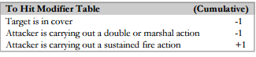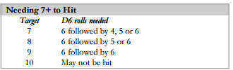
blast markers:
formation receives one each time you are shot at, every time a unit is lost, each one suppresses a unit and stops it shooting
formation is broken when markers equals the number of units in the formation
broken formation must withdraw and cannot take actions - it must try to rally in end phase
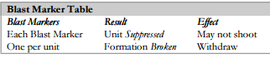
Barrages:
barrages (bps) – first place barrage Template
each weapon needs to be in range and have lOS to at least one unit under the template all units under template are attacked and receive a blast marker
use data sheet, calculate total barrage points effect (add all units blast markers) extra templates are placed touching the first template
Roll to hit, closest units are hit first. barrages give a crossfire bonus
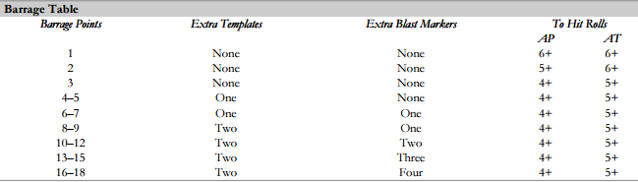
overwatch:
it allows you to shoot after an enemy formation completes a move (any move) or unloads troops.
the unit stays in overwatch until they shoot or undertake a new action in the next turn

Crossfire:
draw a straight line up to 45cm from a front facing unit to a flanking/rear side friendly unit
if the line crosses the gap between two units from the target formation or a unit crossfire is achieved
both units need to have los to the enemy(broken or marching units can’t be used)
units caught in crossfire suffer a -1 save modifier
the first unit destroyed causes two rather than one blast marker
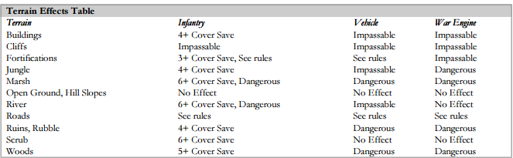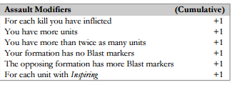
ASSAULTS:
Assaults can be hand to hand or short range firefights. - carry out engage action: Choose target formation: - pick enemy formation
Make charge move: - formation makes a single move, must have one unit within 15cm of the target formation, unit can enter zone of control. - base contact is close combat (max 2 units per defender)
Make counter-charges: defenders with a speed of 30cm can make a 10cm counter charge with 25cm can go 5cm etc
Resolve attacks: close combat for base contact, within 15cm and line of fire use firefight value roll 1d6 for each attacking unit(blast markers do not supress) if roll is equal to or higher than cc rating a
Hit is scored. roll saving throws as normal - no cover saves, if all defenders die and one attacker is left, Attacker wins. Vice versa all attackers within 15cm killed attack fails.
If both sides have units remaining supporting fire can be called. units within 15cm roll to hit using firefight values - allocate hits/save as normal then work out result
Work out result: remove casualties, if one side is wiped out the other wins, if not roll a 2d6 applying modifiers from chart
To the single dice that rolled the highest. The highest one wins the assault.
The loser suffers extra hits equal to the difference in dice rolls with NO saves. With a tie repeat assault steps above. Loser withdraws:- they are broken and receive blast markers for casualties. if unit was already broken the whole formation is destroyed
units within 15cm that did/can lend support get 1 blast marker
Winner consolidates: winner get blast makers equal to lost units (can end up broken does not have to withdraw)winner can move 5cm but not into zones of control
(for intermingled units treat them as a single formation when working out results)

regrouping and broken formations:
a formation is broken when it has more blast markers than units, broken units cannot be selected to take an action in the action phase
A marshal action allows you to regroup. regrouping - roll 2d6 for the formation remove blast markers equal to the highest roll, formations that lose an assault are auto broken
When broken remove blast markers and mark as broken.
Withdrawals: can be made after the action that breaks the formation. its two moves in any direction, if the second is within 15cm of an enemy it is destroyed (can ignore zones of control when moving)
*when a formation is broken it gets no more blast markers in place apply another hit with no saving throw.

THE END PHASE:
both players must attempt to rally formations that have blast markers or are broken and check victory conditions
rally formations one at a time (higher initiative first) roll equal or over initiative value on d6 (inc modifiers)
if test is failed broken formation must withdraw, unbroken stays in place, no blast markers removed
If test passed remove half the blast markers rounding up.
A broken unit that rallies is no longer broken - it counts as having half the number of makers as units - then remove half
Check victory conditions
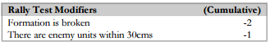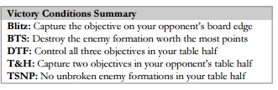
WAR ENGINES:
dc=damage capacity the number of hits needed to kill
movement: can be single units or part of formations – coherency = starting damage x 5cm of another unit in formation
some can transport other units, move to base contact can’t take an action after mounting units that disembark cannot take an action
shooting: allocating hits-allocated against war engines starting damage
v templates war engines directly under the template it takes a number of attacks equal to half its starting damage
when damage capacity reaches zero it is destroyed - one blast marker per hit of damage
critical hits: roll a d6 for each hit on a 6 its a critical hit- see formations data sheet
blast markers: need to be equal or higher than the starting damage capacity (add units in war engine formation ) enemy units within 15cm cause an additional blast marker when withdrawing
Titan killer weapons: when titan killer weapons hit a war engine they cause damage equal to the roll of the sort of dice.
Roll for critical hits as normal they will have a dice roll in brackets if not in brackets they cause one point of damage Damage does not spill over to other units with titan killer shots.
war engine assaults: charge move - can "barge" non-war engines out of the way can barge two units per points of starting damage capacity
close combat and firefights: roll a number of hit dice equal to the war engines starting damage capacity, which can be split between close combat and firefight rolls as you see fit (close combat only apply to base contact and 15cm for firefight
Results: count each point of war engine damage as a casualty. if a war engine loses an assault it takes one extra point of Damage for each point it lost the assault by. Roll critical hits as normal.

AEROSPACE OPERATIONS:
Aerospace units are organised into formations they receive blast markers but cannot be broken or suppressed they cannot be assaulted, lend support to an assault or be used to claim crossfire while in the air while on the ground they are affected normally.
Aircraft: kept off table and set up on the table when taking an action, transporter may be set up with the units already on board
Ground Attack: action test Move to board edge, approach move then attack enemy ground units then disengage in end phase - exit
Intercept: fighters/fighter bombers - action test, set up on table edge, approach move then attack enemy aircraft, disengage in end phase - exit
Combat Air Patrol: fighters/fighter bombers, action test, set up on table edge, can carry out interception in response to ground attack no initiative needed Is made after enemy approach move but before flak fires. Formation stays on cap until they intercept or turn end they can remain on cap into the next turn.
Stand down: the formation does nothing this turn
aircraft approach moves: start on table edge, can travel unlimited distance, travel straight unless turning - turning is on data sheet
Turning- fighters can make a 90 degree turn after at least 30cm of movement must make another 30cm move before turning again
bombers can make a 45 degree turn after a 30cm move and can repeat after another 30cm of movement
fighter bombers- behave as bombers when making ground attacks and fighters under other circumstances
aircraft attacks: ignore terrain for line of sight
aircraft with an aa value - anti aircraft can shoot at other aircraft, roll to hit using aa value, if hits enemy must make a saving roll, aircraft on cap or intercept may add +1 to hit rolls
targets can choose to "jink" all units in formation must do so, they get a 4+ save but lose any potential attacks
Flak attacks - a "free attack2 that does not stop a unit taking actions later they cannot be marching or broken, formations that move hit with a -1 modifier no los required. Ground units can shoot aircraft within weapons range during approach or disengagement moves. - One or the other not both.
aircraft transports: Carry out a ground attack order to transport units. they can pick up or drop off by either landing or air assault
landing: check terrain in landing zone, after landing disembark units within 5cm of aircraft(skimmers/jump packs are 15cm) they can pick up units within 5cm. after embarking/disembarking (disembarking units can’t take an action but they can shoot or fight in an assault) they can then carry out ground attack
Once landed the aircraft is treated as a ground unit, it is destroyed if assaulted, can then disengage when landed then exit in end phase.
Air assault: land as above but units that disembark can assault instead of shooting if this is chosen the aircraft and passengers can enter enemy zones of control. If assault is lost aircraft is destroyed.
Disengagement: aircraft can exit via any table edge- happens in end phase before rallying units.
aircraft blast markers: Caused by intercepts/ground flak, formation can only get one blast marker in in approach and disengagement moves no matter how many units shoot at it. Formation gets a blast marker for each shot down unit; it gets a blast marker if it exits from a table edge other than its own side’s edge.
Aircraft cannot rally as normal, instead take an action test as normal but apply a -1 modifier for each blast marker. All blast markers are removed after the action test despite the result.

SPACECRAFT:
need a battle fleet gothic model to represent the ship, set up before ground unit deployment
Start at table edge and when deployed declare which turn they will arrive, - it cannot be the same as another spacecraft.
Secretly record the drop zone of units using planet fall on paper also where orbital bombardments will fall. (measure distance on table)
spacecraft operation: take action test as normal and carry out actions: After attacks/landings the craft is removed.
Actions: orbital bombardments - no extra initiative test required use 12cm template and centre it on target location - attack units under the template as you would for an artillery barrage
pin point attacks:- can be made on enemy war engines - pick a target anywhere on the table then attack with available pin point attacks - different war engines can be targeted with each (no co-ordinates needed)
Planet fall: only using units with the ability. They are kept off table until landed. You can make planet fall the turn the ship enters play. Carry out after any bombardments/pin point attacks. Take one of the units and place within 15cm of drop zone co-ordinates.
The unit then scatters 2d6 in a random direction (use scatter dice). Any units transported are allowed to disembark immediately on landing or stay on board and disembark later. Landing does not count as movement to trigger over watch. Units landing off table are destroyed. Units that land can take an action later in the turn.

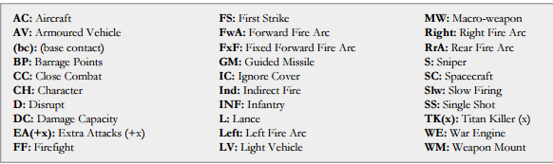
SPECIALIST units:
characters - added into an existing unit in a formation
commanders - can order x3 formations to follow them in assault (within 5cm of command unit) can make an initiative roll ‌(inc -1 mod for blast markers) if failed get a blast marker, if passed all x3 take engage action, treat as single formation 2d6 used to resolve combat
fearless- immune to damage when assault lost and from being broken can choose not to withdraw (only unit effected)
infiltrators- double speed on charge move while ignoring zones of control
inspiring- add +1 to assault rolls
invulnerable saves- second save of 6+ if the first is failed
jump packs-can ignore dangerous/impassable terrain and move over friendly units
leaders-a formation with a leader can remove one extra blast marker when rallying
light vehicles- can be effected by ap and at fire
mounted-count as vehicle for terrain and infantry for everything else
reinforced armour- takes saving throw when hit by macro weapons and reroll a failed save against any non-macro weapon hit
scouts - scout units remain within 20cm of units within their formation and their zone of control is 10cm
skimmers- can fly over terrain that would slow other units down ignoring dangerous/impassable terrain popping up declaration at the start of actions they pop up over terrain, fire then pop down again
snipers-unit rolls separately -if hit can choose which enemy unit is hit and they suffer -1 save modifier
supreme commanders - are commanders and leaders, they get to reroll initiative tests
thick rear armour- ignore -1 modifier when stuck in crossfire
teleport- units can be kept off table appears at the start of any turn place anywhere on the table before strategy roll, it must land within 5cm of friendly unit and outside enemy zone of Control. roll a d6 for each unit on a 1 the teleporting unit gets a blast marker
walkers- get a reroll on failed dangerous terrain tests
slow and steady - some ships can’t be used in the first two turns
support craft- skimmer/aircraft combo - always popped up
self-planet fall- like planet fall - smaller ship can arrive in the same turn as an enemy ship activated as normal , if fails its delayed till the next turn
expendable- a formation does not get a blast marker when an expendable is destroyed inc extra blast markers
tunneler- can be kept off table and appear from the second turn onwards, starts at table edge, secretly write down surface location, arrives your turn 2 in your Half turn three if in enemy half.

SPECIALIST WEAPONS:
anti-aircraft weapons- v aircraft, aa value also can have ap /at values
disrupt-inflict blast marker for each hit rather than each kill, those that fail save do not cause a second blast marker
extra attacks- (+x) units get extra attacks equal to "x"
first strike- weapons with first strike attack first in assault - resolve before enemies make attacks if both have, resolve simultaneously
ignore cover- ignore cover to hit mods and infantry save mods
Macro weapons- no saves unless reinforced armour/invun save. cover saves are ignored(-1 to hit still applies) units on transports only get a save if they would have if hit directly for barrages as normal no save as above, allocating hits?- normal weapons first then macros
single shot- can only be used once per battle
slow firing- take one turn to reload
titan killers- enemy units hit may not take cover or armour save even with reinforced armour, treated as macro weapons
Indirect fire- no line of fire required- friendlies with line of site can spot for firing formation. they can also double their range
they have a minimum range of 30cm.

