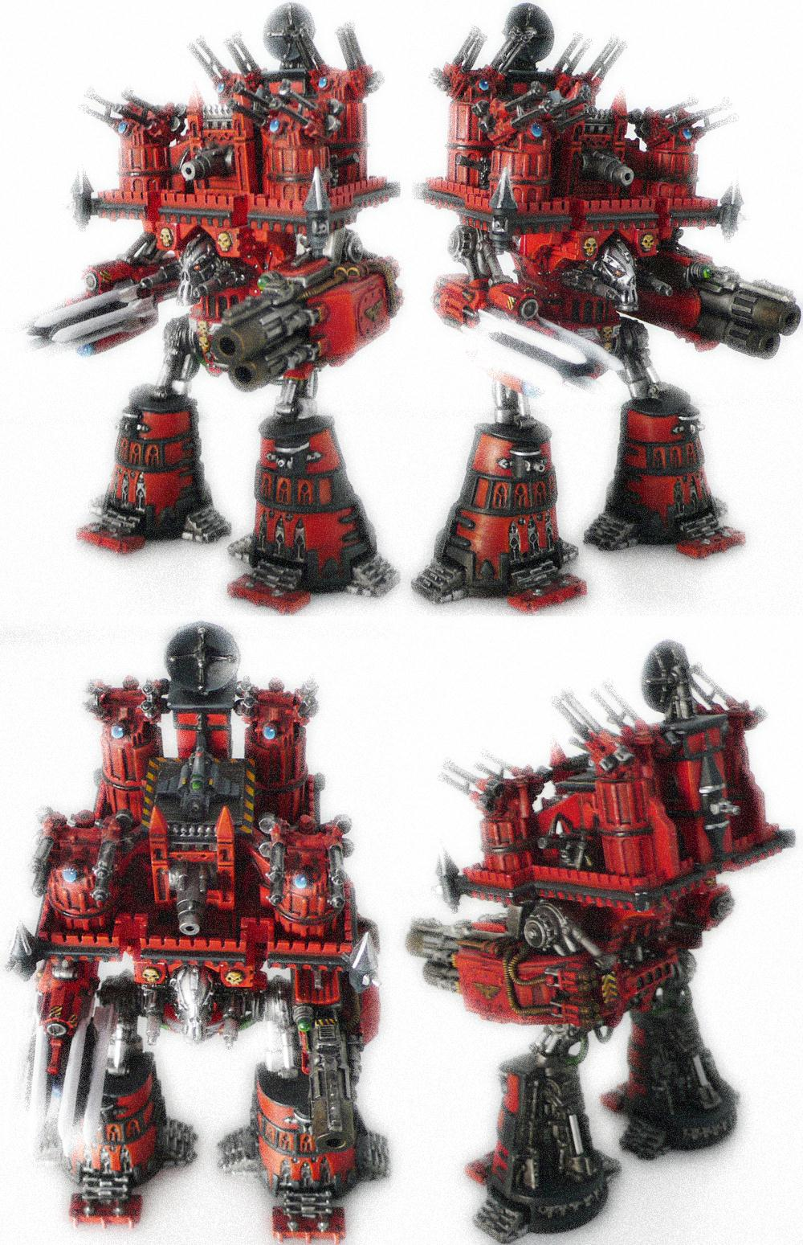

The Warmonger Titan

Table of Contents
Introduction 3
Points Cost: 3
Set Up 4
Warmonger Titan Weapons 4
Sensorium Guns 4
Secondary Weapons 4
Point Defence 4
Flak Batteries (4): 4
Doom strike Launcher: 4
Vengeance cannon: 5
Lysander Spotter Plane: 5
Using the Warmonger Titan 5
Generate Plasma: 5
Allocate Plasma: 5
Warmonger Titan Armour Saves 6
Warmonger Titan Repairs 6
Warmonger Titans in Close Combat 6
Boarding the Warmonger Titan 7
Warmonger Titan Damage Tables 8
Warmonger hit location charts 9
Warmonger Front 9
Warmonger Rear 10
Warmonger side 11

Introduction
The Emperor Titan is the largest type of Imperial Titan, consisting of two classes: the Imperator and Warmonger.

Emperor Titans are immense, mobile fortresses, mounting veritable arsenals of weaponry, protected by void shield generators and armour so thick an Emperor Titan would not be out of place on a planetary defence installation. Emperor Titans are among the largest mobile battle units that can be deployed on a planet's surface. It forms a vital role, employed against the most formidable and overtly powerful enemies, providing massive, destructive and directed power. Emperor Titans employ the same technologies as other Titans but on a massive scale, relying on huge plasma reactors to supply their colossal requirements.

The Warmonger is one of the two variants of the Emperor class, the other being the Imperator. Of these two, the Imperator is a more general-purpose assault platform, whereas the Warmonger is a dedicated fire-support unit with advanced fire control and targeting systems.

The Warmonger Titan is very close in appearance and structure to the Imperator Titan, but they have different roles upon the battlefield. In battle, the Warmonger is usually held back to provide long range fire support due to its large weapons load of support missiles and its massive Anti-Aircraft capabilities. The Warmonger is not quite as capable at Close Assault as the Imperator due to its specified role of Support and Command Control. Emperor Class Titans are known to have existed well before the Horus Heresy and while several Chaos Warmongers are known to exist there are no known Chaos Warmongers.

Move | CAF | Shields | Repair | Notes
Varies | +20 | 12 Void Shields | 4+ | 2+ Psychic save

Points Cost:
The Warmonger has a base cost of 1500 points which is then adjusted as per the missile layout for the Doom Strike launcher.
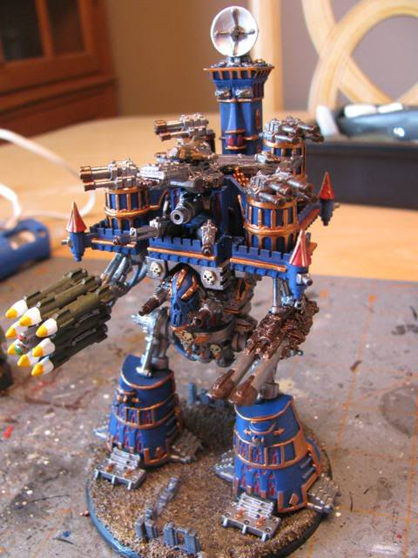

Set Up
Plasma Counters: Eight each of red and green counters are placed off to one side of the data card. Plasma counters represent the energy generated by the titan’s plasma reactor and are placed on the data card as the titan generates and allocates power to the titan’s systems. The green represents normal plasma, and the red represents “overcharged” plasma that can increase performance. Two green plasma equal one red plasma. The Warmonger is capable of generating D6+2 green counters per turn.

Void Shield Counter: One counter of any kind, placed on the Void Shield track. This keeps track of the number of active void shields on the Imperator Titan. At the start of the game, the titan has 12 shields.

Garrison Troops: The Warmonger may carry 12 infantry stands in the bastions.

Warmonger Titan Weapons

Sensorium Guns
So long as plasma is allocated to the fire control centre the Sensorium guns can fire. Sensorium guns cannot be overcharged.

Secondary Weapons
So long as plasma is allocated to the fire control centre the Secondary Battery may be fired.

Point Defence
These weapons fire in the First Fire segment as long as plasma is allocated to the fire control centre.

Flak Batteries (4):
These are dedicated AA guns. They may not fire at non-titan ground targets that are closer than 50 cm.

Doom strike Launcher:
This holds 8 missiles. Before the battle purchase them from any of the titan missiles and add their cost to the base cost for the Warmonger.

Missile Type | Points Cost
Barrage Missile | 100
Harpoon Missile | 75
Vortex Missile | 150
Warp Missile | 125

Vengeance cannon:
The Vengeance cannon requires plasma counters in order to be charged. The number of attack dice is variable and dependent upon the number of plasma counters allocated to it during the orders phase. Each green plasma counter gives two attack dice and each red plasma counter gives three attack dice. It is possible to place both red and green plasma counters in the Plasma Annihilator, but no more than four counters of either colour may be placed in the accelerator chamber at one time. If any ones are rolled for overcharged attack dice, the coolant system has overheated and the weapon needs one turn to cool off.

Lysander Spotter Plane:
This allows the Doom strike Launcher to be fired indirectly like artillery.

Troop Type | Move | Save | CAF | Weapons | Range | Attack Dice | To-Hit  Roll | TSM | Notes
Spotter Plane | 35 cm | 5+ | +1 | Bolters | 25 cm | 2 | 5+ | 0 | Flier, Special

Using the Warmonger Titan

Generate Plasma:
During the Orders Phase of each turn, put D6+2 green plasma counters in the reactor core. The amount of plasma generated should not be kept secret from your opponent. You are not required to use all available plasma each turn, and any left in the reactor will stay there for next turn. At the end of the turn, remove all plasma counters from the data card except those in the reactor.

Allocate Plasma:
The placement of plasma counters determines when the Titan fires, how fast the shields get fixed, how fast it moves and how powerful the weapons are. When allocating plasma, keep your allocations secret until the Titan performs its actions, at which time you must reveal power allocations to your opponent. 2 Green counters = 1 Red counter.

Location | No Plasma | Energised (1 counter) | Overcharged (2 counters)
Fire Control Centre | No Shooting | Fire on Advance | Fire on First Fire
Void Shields | Shields don’t repair | Shields repair on 5+ | Shields repair on 4+
Engines | No movement | 5-10cm in Advance make one 90° turn | 10-20cm in Charge may make one 45° turn
Sensorium | No effect, cannot fire | +25cm to all weapon ranges | Cannot be overcharged
Doom strike launcher | Cannot fire | Fire two missiles | Fire three missiles
Vengeance cannon | Cannot fire | See weapon description

Weapon | Range | Attack Dice | To Hit | TSM | Notes
Flak batteries (4) | 100cm | 4 per battery | 5+ | -1 | AA, Special
Sensorium guns | 50cm | 2 | 4+ | -2
Secondary Weapons (8) | 50cm | 1 each | 5+ | -1
Point defence (16) | 15cm | 1 each | 6+ | 0
Doom strike launcher | See missile description
Barrage Missile | LoS | 8BP | 3+ | -2 | One-shot, Place D6 extra templates when fired
Harpoon Missile | LoS |  | Auto | -2 | Takes over enemy titan if armour save is failed, One-shot
Vortex Missile | LoS |  |  |  | One-shot, Destroys Buildings, Ethereal Psychic, Special
Warp Missile | LoS |  | Auto/3+ |  | One-shot, Destroys Buildings, Ethereal Psychic, Special
Vengeance Cannon | Allocate up to four counters, each one either green or red
Energised (green) | 100cm | 2 | 4+ | -4
Overcharges (red) | 150cm | 3 | 3+ | -6 | Penetrating +3

Warmonger Titan Armour Saves
All armour saves are made on 2D6, as buildings. Yes, Warmongers are incredibly difficult to damage.

Warmonger Titan Repairs
Warmonger Titans have extensive repair functions that allow them to absorb incredible amounts of damage and remain functioning. During the end phase the Warmonger can attempt to repair any damaged location not occupied by an enemy model. Roll a D6 for each damaged location, and on a 4+ the location is repaired. Void shields may be repaired as well. Roll a D6 for each downed shield. If the Void Shields have been energized, the shield comes up on a 5+. If the void shields have been overcharged the shield comes up on a 4+. If no power has been allocated to void shields, then no repair rolls are made.

Warmonger Titans in Close Combat
Warmonger Titans are so large that most vehicles and super heavy vehicles are unable to even scratch them in Close Combat. The Warmonger is invulnerable to Close Combat attack from non-Titan/Praetorian/Knight units. Titans, Praetorians and Knights may engage the Warmonger using the standard Close Combat rules. Infantry have no effect on the titan itself but may fight the troops inside the segment of the Warmonger they are attacking (bastion or fortress). While these units cannot harm the titan from outside, they can engage the units in its bastion or fortress and attempt to damage the Warmonger from within. Only infantry models able to enter buildings
can fight a boarding action.

Boarding the Warmonger Titan
The Warmonger is designed so that the lower legs, or bastions, are completely sealed off from the rest of the Titan. Because of this, the different sections of the Warmonger (left bastion, right bastion and upper fortress) are assaulted as if they were separate models. Boarding actions can be conducted against the bastions by models attacking from ground level. Troops equipped with jump packs, skimmers and troops disembarking from flyers or skimmers can assault the upper fortress. Only models able to actually enter buildings can attempt a boarding action against the Warmonger. Boarders can attack if they are in contact with the model at the start of the Close Combat segment of the combat phase. All troop stands carried by the Warmonger Titan may fire, during the First Fire segment, at models attempting to board. Any restrictions on models that can fire or modifiers for cover do not apply. Additionally, the Warmonger Titan can fire some or all of its armament at the attacking models as long as the attackers are within firing arcs of the weapons and the Titan can fire in the First Fire segment. During the Close Combat segment resolve the boarding action for any surviving attackers:
- Line up all the models attacking the Warmonger Titan.
- Take all the defending troops off the data card and line them up against the attackers.
- If either side has any excess models left over they can be used to double up against opponents.
- Fight Close Combat as normal. Everyone is inside so there’s no bonus for that.
- Place surviving defenders back on the data card.
- Any surviving attackers can now occupy troop stand locations that have been left empty.
- Locations occupied by enemy models are considered damaged (not destroyed) but may not be repaired while occupied by enemy models.

Warmonger Titan Damage Tables

Bastion |  | Bridge
1 – 4  5 – 6 | Section damaged  Section destroyed. Models here are destroyed. If both sections of a bastion in a single level are destroyed the titan falls | 1 – 2  3  4  5 – 6 | Damaged. Repair rolls are 6+ instead of 4+  Damaged. Fire Control requires twice as much plasma  Void shield controls damaged. Shields may not be repaired  Bridge destroyed. Titan Lurches and Falls
Engine |  | Guard room
1 – 2  3 – 4  5  6 | Movement reduced by D6cm for next turn  Engine damaged. Titan may not move until repaired  Engine destroyed. No movement or turning  Engine destroyed, roll on Gyro damage table | 1 – 3  4 – 6 | Section damaged  Section destroyed. Models here are destroyed
Gyro |  | Leg
1 – 2  3 – 6 | Gyro damaged  Gyro section destroyed turns reduced by 45°. If all three gyros destroyed the titan falls | 1 – 4  5 – 6 | Leg damaged. Maximum move 10cm  Leg destroyed, titan falls
Mind unit |  | Reactor
1  2  3  4  5 - 6 | CAF halved and may not fire primary weapons this turn  Partially destroyed. CAF permanently reduced by 2d6 each time this choice is rolled  Partially destroyed. Roll D6 each time you move 1-2 turn 45° right, 3 – 4 turn left 45° 5 – 6 go straight  Partially destroyed. Roll d6 each time you fire a primary weapon. 1 – 3 you target nearest unit friend or foe  Destroyed, titan falls | 1 – 2  3 – 4  5 – 6 | Damaged. Lose d3 plasma counters and use aim dice to see where each one goes. That location takes a hit at -4 TSM  Damaged. No additional plasma generated  Destroyed and titan vaporised! All units within 4D6cm hit with -1 TSM. Put down crater
Reactor link |  | Sensorium
1 – 3  4 – 5  6 | Damaged. Plasma may not be placed in engines  Destroyed. Plasma may not be palced in engines. Roll aim dice to see if adjacent section hit at -4 TSM  Destroyed as 4 – 5 above and roll on reactor table | 1 – 3  4 – 5  6 | Damaged  Destroyed. All weapons fire at -1 to hit and Psychic save is now 4+ (-2 each time this is rolled)  Destroyed and roll D6 for all troops on board, on a 5+ troops destroyed
Tower |  | Weapon coupling
1 – 3  4 – 5 | Section damaged  Section destroyed, anything above is counted as destroyed | 1 – 2  3 – 5  6 | Damaged. Only fire in direction weapon is pointing and cannot add plasma  Destroyed, weapon falls off titan, anything below hit at -4 TSM  Destroyed as 3 – 5 above, roll d6 for further damage to adjacent areas, 1 – 2 Guard room, 3 – 4 Landing pad, 5 – 6 Reactor (normal to save)
Primary Weapon (Doon Strike or Vengeance cannon) |  | Other weapons (includes AA battery)
1 – 3  4 – 5  6 | Damaged  Destroyed  Destroyed and hits all adjacent areas at -3 TSM with +1 to damage roll for each unused plasma counter | 1 – 2  3 – 4  5  6 | Damaged  Destroyed (if AA battery – 4 attack dice per weapon destroyed)  Destroyed and scatters 2d6cm, anything below hit with -2 TSM  Destroyed as above and roll to damage ONE adjacent area
Void Shield generator |  | Landing platform
1 – 3  4 – 5  6 | Damaged. Void shields may not be repaired  Destroyed, all remaining void shields fail  Destroyed, as 5 above plus roll D6 to damage 1 – 2 Reactor, 3 – 4 Sensorium, 5 – 6 Mind unit (normal save) | 1 – 3  4 – 6 | Damaged (if Lysander still on board roll normal save otherwise destroyed)  Destroyed if Lysander aboard it is also destroyed otherwise it may not return to the titan
Titan falls
Roll scatter dice to determine direction. All units underneath are destroyed. Units with a hit location template take D6+1 hits ignoring shields and armour.

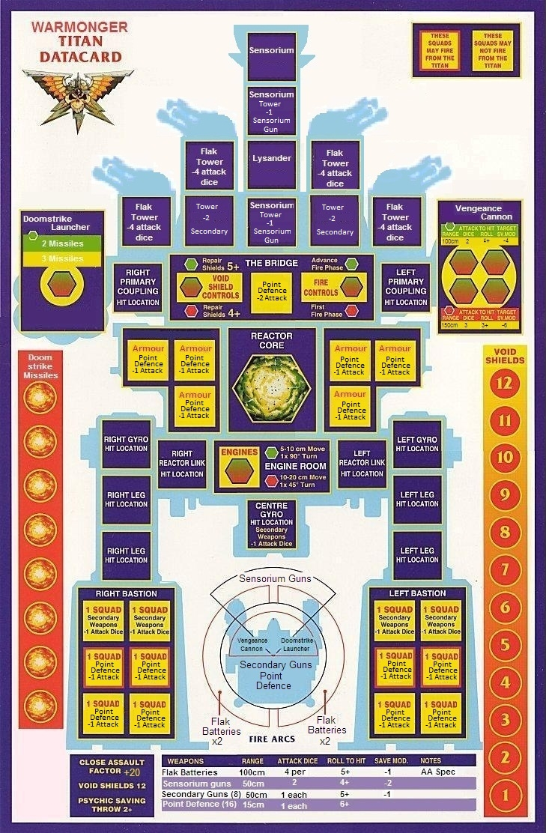

Warmonger Hit location charts

Front Rear Side



