Wartorn Beta Rules Battle Report 1500 points, Dread Elves versus Orcs and Goblins
In my third game of the Wartorn Rules I used a Dread Elf army versus a horde of Undead at 1500 points.
The Armies
The Dread Elves (1504 points)
Zalizar, a Dread Elf Sorceress with her own Hydra Hide Cloak, retinue of Guards, Acolytes; with the following spells, Darkness, Aim for the Heart and Shatter Soul. @ 129 points
Zalsmushi, a young Dread Elf Sorceress with her own Hydra Hide Cloak and knowing the Aim for the Heart spell, @79 points.
2 x Formations of Dread Elf Spears @ 222 points each
2 x Formations of Dread Elf Crossbows @168 points each
A Formation of Dread Elf Outriders @196 points
One Formation of Dread Elf Shadows @ 108 points
1 x Formation of War Lizard Knights @ 212 points
The Undead (1507 points)
Vampire Lord armed with a magical Exotic Weapon and an Invulnerable Save @ 63 points
Necromancer 1, with an Invulnerable Save and the following Spells, Wither, Decay and Animate Dead @ 125 points
Necromancer 2, with an Invulnerable Save and the following Spells, Wither, Decay and Animate Dead @ 125 points
3 x Formations of Spear Armed Skeletons @ 192 points each
1 x Formation of Skeleton Archers @ 210 points
2 x Formations of Wight Cavalry @ 204 points each
Deployment
The Dread Elves won the roll for choosing a side and chose the Southern side of the battlefield to deploy from. They used the fields and village to protect the left flank, both Crossbow Formations to hold the centre and the Spear armed Dread Elves to flank enemy units in the centre. The Outriders and War Lizards to counter the Wight Cavalry deployed opposite to them.

The Undead plan was simple, advance the 3 Formations of Spears up the Battlefield, using the Animate the Dead spell to increase their numbers before committing them to combat. The deadly Wight Cavalry to challenge their right flank and then the centre; the Vampire Lord was there to aid their Command Tests and Combat power.
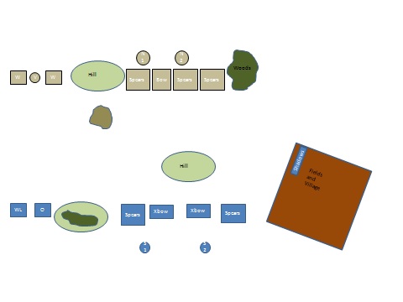
Turn 1
The Undead won the roll to commence moving, with the exception of the Skeleton Archers, all Formations moved ahead. The Dread Elves countered with March Moves of their own, the Outriders and War Lizards held their ground, waiting to see which way the Wight Cavalry would continue. A Formation of Dread Elf Crossbows confused their orders and advanced slowly toward the Undead Horde. The Necromancers commenced their turns by raising more Undead to bolster 2 units of Skeleton Spear armed Formations. The Dread Elf Shadows held their ground, hiding in the fields, waiting for the right moment to unleash their fury.

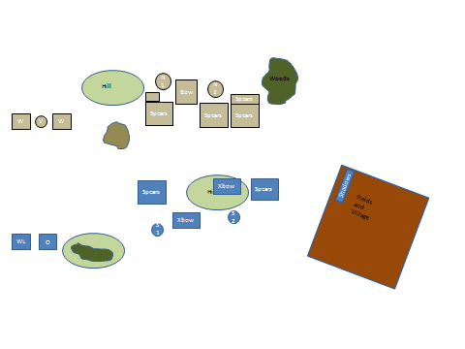
Turn 2
The Undead won the roll again to see who commence moving first; they managed to Seize the Initiative and got both Wight Cavalry Formations to advance in good order. The War Lizards did not charge, they pawed the ground, butted heads and roared their defiance at their masters (they had rolled double 6 for their Command Test), the Outriders tried to Move and Shoot, but even their fierce horses were unsettled by the stench of approaching Living Death and they could barely hold their ground (they had rolled a 6,5 to attempt their Move and Shoot order). Zalizar was suspecting treachery within the ranks and was beginning to feel the talons of doubt and impending doom around her brain…perhaps her attempt at showing off to her Lord would end in disaster today? The closest Formation of Dread Elf Spears saw the threat and wheeled to counter the Wights. Zalizar (S1) managed to cast Shatter Soul on the Undead Spears to her front, but the casualties were quickly re-animated back into their Living Death existence by a Necromancer. The enlarged Spear armed Undead Formation on the extreme Flank also had extra Undead added to it by the second Necromancer (the Formation had grown considerably by 4 Stands, almost doubling in size!). Several casualties were caused by the Dread Elf Crossbows, but these would soon be replaced.
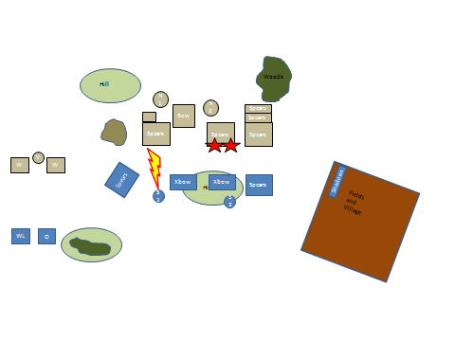

Turn 3
The Undead again won the roll to see who would commence moving first. The Wight Cavalry charged home against the War Lizards and Outriders. Zalizar saw an opportunity to kill the Vampire Lord, summoning all of her magical power, she cast Shatter Soul on the monster of undeath, but it prevailed! The Dread Elf Spears gritted their teeth and charged the wounded Vampire, despite losing many of their troops, they slayed the dangerous creature. (The Vampire Lord did cause 5 wounds, but the Dread Elf Spears managed to take his final 2 wounds and cut him down after the combat with the Wight Cavalry had taken place). Elsewhere, the Undead Spears charged home against the Dread Elves, causing many casualties; the Dread Elves only just held under this onslaught, outnumbered and beaten in combat their morale started to flag, but they held all the same. The Dread Elf Shadows saw an opportunity, they moved forward and riddled the second Necromancer with their deadly crossbow bolts; he survived this fusillade only due to his invulnerable save. The Wight Cavalry charging into the War Lizards had met their match, the imperious Dread Elf Knights cut down the Undead creatures, forcing more casualties as the Wights became unstable due to losing the combat. The Wights that had charged the Outriders had an easier time, almost killing half of the Dread Elves to their front…but they held. (the Outriders lost 5 wounds).
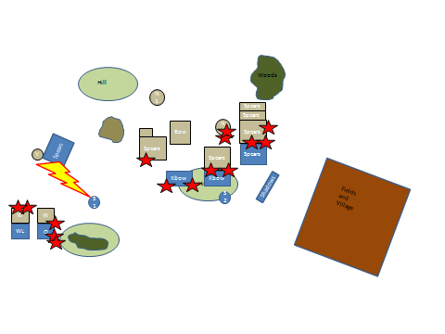
Turn 4
With the Vampire Lord vanquished, the Dread Elves won the roll to get the first turn. The Shadows finished their task of despatching the second Necromancer, another hail of crossbow bolts killed him and his remaining bodyguard easily. Zalizar moved to help the Dread Elf centre and killed some Skeleton Spears, who were re animated by the first Necromancer, but the tide of magical power had changed and the Dread Elves now had the upper hand in this area. Zalsmushi aided the shooting of the Dread Elf Crossbows, some of the recently reanimated Skeletons fell victims to crossbow bolts for a second time. Elsewhere the Undead Spears won their combats again, the Dread Elves only just managing to hold their ground but steadily losing their self-confidence and morale. Despite their better martial skills they were heavily outnumbered and no help appeared to be forthcoming. The War Lizard Knights continued to destroy the Wights to their front, whilst the Outriders paid a heavy toll in blood in holding off the Wights to their front (they suffered another 5 wounds), but they still held against the odds. The Vampire killing Dread Elf Spears had manoeuvred themselves into the rear of the Wights, ready to deliver a fatal blow.
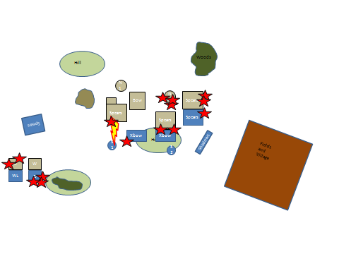
Turn 5
The Undead commenced the turn by trying to activate their Archers, but they failed to respond to any commands. Zalizar saw an opportunity to kill off the last Necromancer, she brazenly moved ahead and concentrated all of her power into a single Soul Shattering Spell, but the invulnerable save afforded by the Necromancers Soul of an Innocent Charm dissipated most of the damage (it saved 3 of the 4 wounds caused by Shatter Soul!). The Necromancer countered with his own spell of death but Zalizar used all of her skill to dispel it (they both rolled 4 dice and both scored 18, this was a close battle). The Dread Elf Shadows now conducted another battle winning move and flank charged the Undead Spears grinding down the Crossbowelves, Zalsmushi also threw herserlf (and her bodyguard) into the same combat. The combined attack of the Shadows and Zalsmushi destroyed the Undead Spear Formation, but the Crossbowelves were down to their last Stand. Likewise, the other Crossbowelves in the centre of the battlefield were holding against a large Formation of Undead Spears, but they finally succumbed to their fear of the living dead, they fled. The Undead Spears were not able to take advantage of this, but continued their advance towards the fleeing Dread Elves. The Dread Elf Spears behind the Wight Cavalry steeled themselves and charged, they couldn’t get past the armour of the Wights; who destroyed the last of the Outriders. The Spearelves held their ground but their self-confidence was shaken dreadfully. Meanwhile the Dread Elf Knights finally destroyed the last of the Wights to their front.
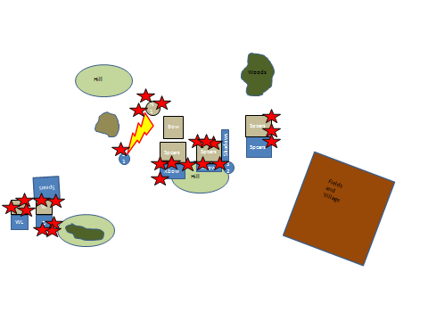
Turn 6
The Dread Elves commenced the last turn with Zalizar again concentrating all of her magical power into destroying the last Necromancer, which she did with ease. The Dread Elf Knights flank charged the second Formation of Wight Cavalry and in a display of martial prowess, destroyed them all. The Dread Elf Shadows once again threw themselves into combat, charging the rear of the Undead Spears pursuing the recently broken Crossbowelves; they totally destroyed the Skeleton Spears. (8 attacks, 8 hits, 8 wounds. In the right circumstances these guys are AWESOME! Just like my WHFB Dark Elf Shades! They will definitely feature in most of my Dread Elf Armies). With no Characters nearby the Undead Archers stood still, silent and unmoving. The Dread Elf Spears on their right flank drew their combat against their Undead enemy, but now they were no longer outnumbered! The Dread Elves had secured themselves a costly victory. 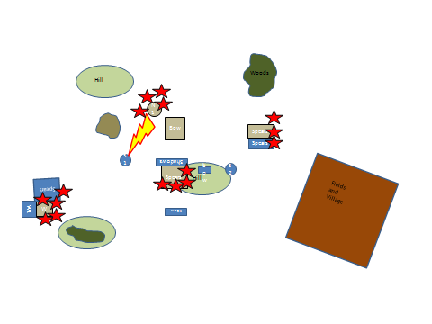

After Action Review
There were a number of changes to the rules that I tried out during this battle:
- Formation deployment – only 2 Stands in the front of each Formation, the Dread Elf Crossbows were not as effective due to their second rank not being able to shoot.
- The Dread Elf Spears also were not quite as effective, only being able to deploy 2 Stands in the front rank, with a depth of 3 ranks.
- Command Test – I made a Command Test for every activation of a Formation; a Formation could use the Command Value of a Character within 20 cm to attempt an activation, if the Character failed, then the Formation could use its own Command Value to attempt an activation, if that second test failed then the Formation just stood still. Dumb, dumb, dumb. This led to the War Lizards not charging (why would the elite of Dread Elf society not charge a pathetic parody of themselves, why would the Outriders, {mounted Scouts almost without equal} not move and shoot the Wight Cavalry to the front by moving to their flank and then shooting them? Again, a unit of Crossbowelves in the centre failed to shoot at the Undead Spears to their front, the same unit they had shot at last turn (yep, they rolled 6,6 to use a Character’s Leadership to shoot, they then rolled 6,5 to use their own initiative to commence shooting…arrrggghh!) Sorry Blindhorizon, this was an example of command and control gone too far, disregard my suggestion to use a Command Test on every single activation attempt. Instead I propose that a Command Test is required to Charge (willing to try this out, but acknowledge your suggestion to make it only against Fear/Terror causing Formations with a penalty against each); Move and Shoot, March Move or Change Formation (also could be used to get rid of Demoralisation Markers).
- Scouts, can remain hidden as long as they are in concealing terrain and more than 5cm from any enemy Formation; deployed and seen once they move of shoot. Dread Elf Shadows, love them!
- I tried using the Formations in the intended way Blindhorizon had suggested, that is each Formation (apart from single Stand Units) would deploy with 2 Stands in the front rank, with remaining Stands placed behind these first 2 Stands. This lowered the effectiveness of the Dread Elf Crossbows a bit, it also lowered the superiority of the Dread Elf Spears not being in 2 ranks of 3 Stands; where their superior martial skills could have made a difference to most combats.
- I think the Undead Spears with their 4 attacks per stand were just a little too good, but then again the Undead had a lot of great dice rolling rounds…but the Dread Elves managed to hold where they needed to just long enough to destroy the Undead.
This was a very close battle, the Dread Elves were taking casualties from magic and shooting, the Undead were enlarging the size of the 2 Undead Spear Formations and a couple of bad Command Tests (these rules have now changed) left the Dread Elves in a very uncomfortable postion…which they managed to come back from…Just.

Points.
- Always take the Dread Lord, Command Value 9 does make a difference!
- Give the second Sorceress more spells!
- Be very careful of Character placement, they can succumb easily to Spell and Shooting.
- Combat Phase, who determines the order of Formations involved in HTH combat?
This was a close battle, not all of the rules used will make it into the next version of rules (a Command Test for every single activation – Gone! What was I thinking there?).

I had fun, both as the Dread Elf and Undead player.

