Wartorn Beta Rules Battle Report 1500 points, Dread Elves versus Orcs and Goblins
In my second game of the Wartorn Rules I used a Dread Elf army versus a host of Orcs and Goblins at 1500 points.
The Armies
The Dread Elves (1559 points)
Lord Kulhaq, the Enslaver, riding “Death” his War Lizard, armed with a magical sword (counts as Exotic Weapon) and wearing Heavy Armour with a War Hydra Cloak providing a 5+ Invulnerable save. Accompanied by his personal retinue of armoured War Lizard Knights. 55 points
Zalizar, a Dread Elf Sorceress with her own Hydra Hide Cloak, retinue of Guards, Acolytes; with the following spells, The Dreaded Terror, Aim for the Heart and shatter Soul. @ 129 points
Zalsmushi, a young Dread Elf Sorceress with her own Hydra Hide Cloak and knowing the Aim for the Heart spell, @79 points.
2 x Formations of Dread Elf Spears @ 222 points each
2 x Formations of Dread Elf Crossbows @168 points each
A Formation of Dread Elf Outriders @196 points
One Formation of Dread Elf Shadows @ 108 points
1 x Formation of War Lizard Knights @ 212 points

The Orc and Goblin Horde (1585 points)
Gronk Teef-Nasha, Orc Warlord with an Exotic Weapon and Orc Glyphs @ 55 points
Orc Warlord @ 49 points
Orc Shaman with the following Spells: Face Punch, Stomp and Grosh is with Us @ 125 points
2 x Formations of Goblin Spears @ 150 points each
1 x Formation of Orc Archers @ 216 points
2 x Formations of Orc Warriors @ 198 points each
2 x Formations of Orc Boar Cavalry @ 172 points each

Deployment
Both forces faced each other across a battlefield with a hill in the middle and some wooded terrain to their flanks. (Yep I got lazy and used exactly the same terrain setup from my first battle and very close to the same Orc and Goblin army as well).

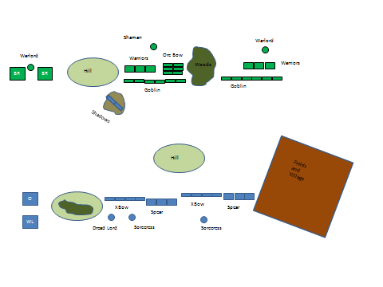
Hopefully you will be able to tell which units are what from this basic map. The Dread Elf Shadows had deployed forward in an area of rocky rough terrain with scrub, so I allowed them to be Hidden until an enemy unit came within 5 cm of them (didn’t happen) or if they moved or commenced shooting..
The Dread Elves won every roll for deciding who deployed first (they forced the Orcs to commencing deploying first),or who was to take the first turn (on the first turn only they forced the Orcs to commence moving first); except for the last turn, but by then the battle had been well and truly decided.
The Orcs had deployed both Goblin Spear armed Formations in a single rank of 6 Stands each. This was to provide mobile cover to the 2 Orc Warrior Formations deployed behind them against the Dread Elf Crossbows. The Orc Boar Riders had been placed last on their right flank, the plan being the Goblins would be the target of most Dread Elf Archery, the 2 Orc Warrior Formations would hold the centre of the battlefield allowing the Orc Boar Riders to come crashing down on the flank.

The Dread Elves, just on 90cm away from the Orcs, deployed both units of Crossbows in a single rank as well, with both Spear armed Formations arranged with 3 Stands in each of the 2 ranks, just like the Orc Warriors. A Formation of Dread Elf Outriders provided cover for the Dread Elf War Lizards. Zalizar deployed on the left flank, the remaining Dread Elf Sorceress, Zalsmushi, deployed on the right flank.
Turn 1
Though winning the roll to get the first turn, the Dread Elves forced the Orcs to commence moving first. The Dread Elves, outnumbered were worried about a double charge from the Lance armed Boar Riders concentrated on one flank. Bothe the Orcs and Dread Elves made several attempts to locally gain the initiative and issue a second order, the Orcs failed half of the time, the Dread Elves only once (the Spears on the Dread Elf right flank). Both of the Goblin units failed to carry out a March Move, hampering the Orc advance in the centre and Orc left flank. Indeed, the Goblins on the left flank also failed to carry out any order.
The Dread Elf Shadows sprung their ambush, unleashing a hail of crossbow bolts into the Orc Warriors, causing 3 wounds. 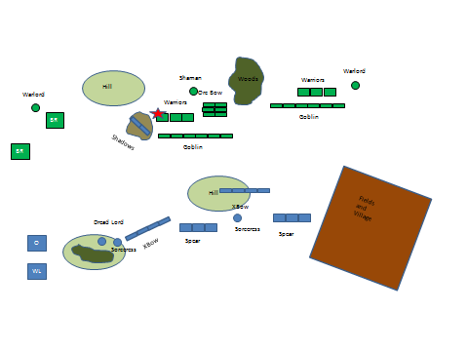
Turn 2
The Dread Elves moved up their Spears to cover the Crossbows, the Orc Boar riders continued their advance, both of the Sorceresses were able to cast Aim for the Heart on each Crossbow armed unit and the Outriders, allowing these units to move and shoot while maintaining a high rate of accuracy. The combined shooting of the Outriders and one crossbow unit decimated the closest Orc Boar Formation, killing half of them! The Shadows killed yet more Orc Warriors, but then were targeted by the Orc Shaman, who managed to cast several Face Punch spells on them, and removing a Stand. The Dread Elf War Lizard Knights waited patiently, sizing up the intent of the Orc Boar Riders, playing a deadly cat and mouse game of who would be able to charge the other. 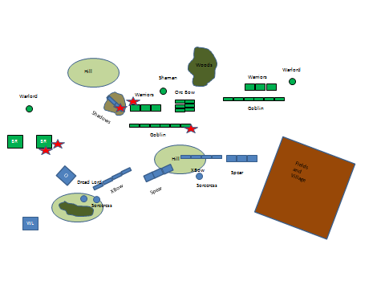
Turn 3
Maintaining the initiative, and being able to successfully order two formations to move, one after the other, helped the Dread Elves considerably. Again, both Sorceresses were able to cast Aim for the Heart, this caused so many wounds on the Orc Boar Riders that the last remaining Stand was reduced to 2 wounds only! But the Orc Archers had managed to get a round of shooting into the Crossbows on the left flank first, slaughtering the Dread Elves and removing 2 Stands.
The Shadows targeted the Orc Shaman in revenge, killing a large number of his bodyguard, but not enough to kill him out right (caused 3 wounds though!). They in turn were destroyed by the magical power of the Shaman.
The large Formation of Orc Boar Riders thought they would seize their chance, after seeing their compatriots almost destroyed by archery fire, declared a charge at their nemesis, the Dread Elf War Lizards, but fell just short of the distance!. Seeing the Orc Boar Riders tire, the War Lizard Knights declared their own charge and shattered the Orc Boar Riders, making them break from the ensuing combat, leaving many dead Orcs behind (8 wounds caused vs 2!).
Lord Kulhaq, displaying his greatness, his martial power, and wishing to save his untouched Formation of Crossbows from the Orc Boar Riders, charged and killed the remaining Orc Boar Riders.
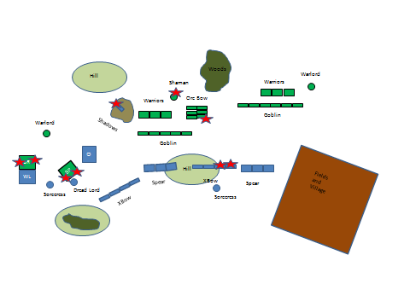
Turn 4
Gronk Teef-Nasha surveyed the battlefield, he was almost surrounded, his Orc Boar Cavalry had been decisively defeated. He bellowed his rage, issued a challenge and charged at Lord Kulhaq. The Dread Lord, grinned evilly and met the charge head on, wounded the great Orc brute and charged down his foe, grinding the Orc Warlord into the ground. The Dread Elf War Lizards managed to catch the fleeing Orc Boar riders and quickly despatched them as well. Zalizar stepped forward and used her spells to kill off the Orc Shaman, dramatically changing the balance of magical power. The Dread Elf left flank commenced a large re-alignment to concentrate on killing the rest of the Orc Horde. The Dread Elf Spears charged the Goblin Spears and massacred them, running down many as they tried to flee and continued their charge into the Orc Warriors stationed behind. The Orc Archers killed off the last of the Crossbow Dread Elves to their front with massed bow fire.
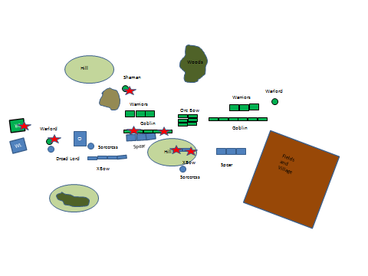

Turn 5
The Dread Elf left flank regrouped and commenced its unstoppable advance to the centre of the battlefield. The Orc Bows spied the lonely Zalsmushi and despatched her bodyguard, dispersed her acolytes and forced her from the field of battlefield under a hail of arrows. The Dread Elf Spears only just managed to beat the Orc Warriors in melee, but they Orcs failed their leadership test, they started to flee and were cut down to an Orc in the ensuing pursuit.
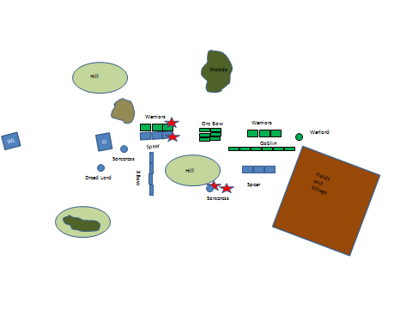
Turn 6
The Dread Elf Spears on the right flank charged the Goblin Spears, they had suffered casualties from the Orc Shaman and the Orc Archers previously; the subsequent combat phase saw the outnumbered Dread Elves take further casualties….but they held…..just. The Dread Elf left flank continued its advance, the Crossbowmen inflicted several casualties on the Orc Archers, as did Zalizar with concentrated magical power. The Orc Archers returned their own archery storm, but it inflicted very few casualties. Panic had started to spread amongst the Orcs and Goblins, their General and Shaman dead, their cavalry dead and the Dread Elves were fixing their front and manoeuvring into a devastating flank attack.

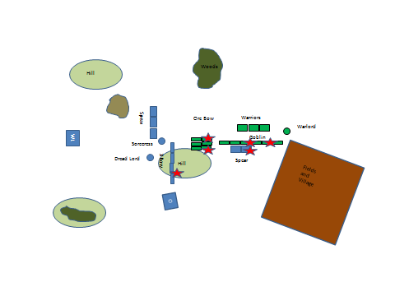
Turn 7
In an attempt to stem the Dread Elves advance, the Orc Warriors turned to met the threat, the Orc Archers died under a storm of magically aided crossbow bolts form the Outriders and Crossbow armed Dread Elves. The Orc Warlord managed to flank charge the Dread Elf Spears, who finally fled after suffering so many casualties, the Goblin Spears did not catch them.
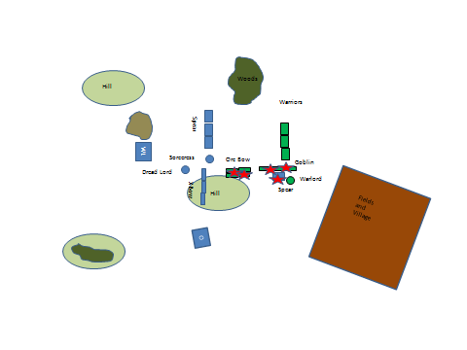

Turn 8
The Orcs finally won the initiative to determine who would get the first turn, but as they were out of charge range there was not much they could do. Zalizar caused many casualties from her spells before the Dread Elf Spear charged home and routed the Orcs completely. Meanwhile the Goblin Spears took many casualties from the Dread Elf Crossbows and Outriders.

The Dread Elves had crushed their enemy, slaughtering many and taking many slaves as well.
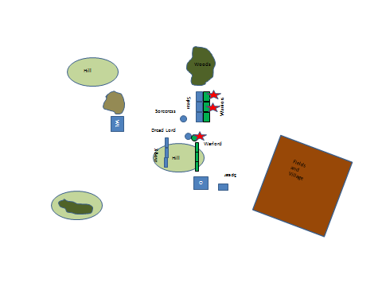
After Action Review
Although outnumbered, the Dread Elves had correctly identified the main axis of the Orc attack, the Orc Boar Riders and concentrated their army to destroy this threat first, before regrouping and mangling the remainder of the Orc horde. The Orcs had been hampered by their inability to get one formation move immediately after another. The Dread Elves had exploited their higher command to activate a Sorceress to cast Aim for the Heart onto Crossbow armed formations, then have one of these formations move and shoot with devastating effect. The late but expertly timed charge of the Dread Elf War Lizards finally broke the Orc right flank, and exposed their General who was quickly despatched.
The Dread Elf Shadows caused many casualties on the Orc Warriors and Shaman in the middle of the battlefield, but due to some poor dispel dice rolling, they died too quickly. (Could skirmishers and/or Scouts take ½ damage from spells due to being so dispersed, could they also be at -2 to hit from missile fire as well?).
The Outriders also performed admirably, they had baited the first Orc Boar riders too close, remained just outside of a charge that would have required too much movement tied up in a wheel for the Orc Boars to successfully charge them. I allowed all 4 Stands to shoot due to their dispersed nature (normally only the first rank of a Formation armed with Exotic Ranged Weapons is allowed to shoot; the Outriders were formed up in a 2 Stand Front, with 2 ranks in total, ie an 80mm x 80mm footprint).
The magically aided shooting due to the continued successful casting of Aim for their Hearts by both Sorceresses also caused many casualties; especially against the first Orc Boar unit (about 80% of their casualties were caused by magically enhanced shooting).
The Orcs were also sometimes unlucky; twice some of their Formations had only just lost a combat phase by a margin of 1 but then subsequently failed their Command Test and fled, only to be completely wiped out by pursuing Dread Elves (who with a Movement rate of 20cm roll an extra dice than the Orcs). However the Orcs had made many armour saves that were above the average, and at times the Dread Elves had shooting or melee results slightly below the average.
The Orc plan to have the Boar Riders control a flank and have the Goblin Spears screen the rest of the Orc Army was sound, but despite the presence of Orc characters, the Goblins consistently failed to make March Moves. This lack of command and control hindered the Orc left flank considerably and helped the Dread Elves concentrate on the Orc right flank and centre. The Orcs were also slightly unlucky in the charge of the Orc Boar riders falling short by 2cm, this led to them being counter-charged by the War Lizards; with Trample, Exotic Weapons and Heavy Armour, the War Lizards caused 8 unsaved wounds on the hapless Boar Riders. Dread Elf War Lizards rock, but they are the Elite of Dread Elf society, so they should.

